The use of *Saccharomyces cerevisiae* to remove copper from wastewater

# 

# Junior Research Lab 2023

Agathe Lemaire

Yuki Iwamoto

Florencia Criado

Tutors:

Irene De Guidi, Institut Agro, INRAE UMR SPO

Tristan Jacqui, Thésard CIFRE UMR SPO, Lallemand

INDEX

1. Introduction
   1. Waterwaste
   2. Situation in Bangladesh
   3. Bioremediation
   4. The role of Saccharomyces cerevisiae
   5. Hypothesis
2. Methods
3. Results
4. Discussion
5. Conclusion
6. References

# Introduction

## Water waste

Fresh water is the primary source of human health, prosperity, and security. Access to this resource has become a main priority for most of the countries in the world, as it has begun to be scarce. Regardless of this situation, the UN estimates that the amount of wastewater produced annually is about 1,500 km3 (UN WWAP 2003). Water pollution is one of the global challenges that society must address in the 21st century aiming to improve water quality and reduce human and ecosystem health impacts. Industrialization, climate change, and expansion of urban areas produce a variety of water pollutants (Zamora-Ledesma et at, 2021). The main sources of pollution have been identified as anthropogenic (UN, 2020; Zamora-Ledesma et al, 2021). It has been a consequence of the increasing

population, rapid industrialization, increasing urbanization, and careless utilization of natural resources (Carolin et al., 2017; Vardhan et al., 2019).

As a result, the presence of dangerous materials for both the human population and the environment have risen. Heavy metal ions are among the most released contaminants, provenient from the industry and the agricultural activity. Heavy metals and metalloids are elements presenting an atomic density greater than 4 g/cm3; therefore, they include copper (Cu), cadmium (Cd), zinc (Zn), lead (Pb), mercury (Hg), arsenic (As), silver (Ag), chromium (Cr), iron (Fe) and platinum (Pt) group elements ( Zamora-Ledesma et al, 2021).

Wastewater effluent released from metallurgical, chemical, textile and leather industry are the main sources of release of these heavy metals into water sources (N. Sharma et al., 2021; Saleh et al., 2022). All around the world, studies have shown higher concentrations than the maximum allowed values for drinking water in rivers and lakes. Because of their inability to biodegrade, they tend to bioaccumulate, resulting in polluting the ecosystem and inducing multiple organ damage to multiple organisms. These effects, as well as the potential ecological impacts of heavy metals, require the development of technologies to efficiently remove them from water.

Copper (Cu) is a frequently encountered metal contaminant in municipal wastewater. It has adverse environmental effects on receiving water bodies and reduces the quality of the biosolids below the standard required for their use as fertilizer or safe disposal. Exceedances often relate to various industrial sources and the use of Cu-containing pesticides in conventional and organic agriculture (Žvab et al., 2021). Even though living organisms require Cu in order to achieve metabolic processes, high concentrations have proven to impact negatively on them. Free or weakly complexed copper can also be harmful to humans (Brewer, 2009). The negative impacts and different limits levels are presented in Table 1.

Table 1.

Sources, and toxic health effects of copper (II).

| Industry | Health effects | Permissible limits (mg/l) | | | References |
| --- | --- | --- | --- | --- | --- |
| BIS | WHO | USA EPA |
| Plastic, electroplating, tannery, paper, steel, battery, pigment, fertilizer, circuit board and textile | Nervous system damage, cancer, abdominal pain, headache, kidney impairment, vomiting, liver and respiratory problem, | 0.05 | 1.5 | 1.3 | Bilal et al. (2013); Al-Saydeh et al. (2017); Khan et al. (2021) |

Environmental degradation occurs that destroys natural biota of soil, air and water by altering the physicochemical properties. Hence remediation of these heavy metals is important to protect the environment (Saravanan et al., 2023). The challenges, in terms of technological innovation, knowledge management, research and capacity development, are to promote the generation of new tools and approaches through advanced research and development, and, equally as important, to accelerate the implementation of existing knowledge and technologies across all countries and regions (FAO 2020).

## 

Heavy metal pollution of rivers from industrial discharges is a major issue across the world, especially in rapidly developing countries such as India and Bangladesh.

The Buriganga river system in central Dhaka, the capital of Bangladesh (Figs. 1 and 2), is highly polluted (Ahmad et al., 2010; Islam et al., 2015a, 2018; Kamal et al., 1999; Whitehead et al., 2018). Thousands of factories discharge waste into the river system of the Greater Dhaka Watershed (Ahmed et al., 2015; Alam, 2008; Asaduzzaman et al., 2016; Islam et al., 2014; Tamim et al., 2016).

One study shows how polluted the Buriganga river is as it flows through Bangladesh. The result is presented in Table.2 .

Table.2

observed metal ranges from the complete water quality data set (ppb μg/L) (BDL: below detection limits)

| Metals | Observed December 2017 | Observed December 2018 |
| --- | --- | --- |
| Copper | 0.375–6.669 | 0.947-9.053 |
| Aluminium | 2.863–12.151 | 6.481-53.226 |
| Iron | 0.678–5.024 | 1.911-12.779 |

The problem of heavy metal pollution is not only in this river, but also rivers all over the world especially in the developing countries.

## 

Removal of trace metals (in the 10/100mgL 1 concentration range) from wastewater is costly and challenging to achieve with the electrochemical and physicochemical methods typically employed (Žvab et al., 2021). The ancient methods demand an important amount of chemical and energy resources, obtaining final products that still need specific disposal.

A current alternative to remove heavy metals from water is biosynthesize organic or inorganic metals that will react and allow their capture and removal (Fig _). This mechanism can be carried out by prokaryotic and eukaryotic microorganisms during a process called bioremediation.

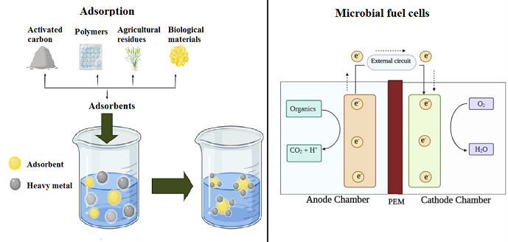

Fig _. Non-conventional treatments for removing heavy metals from wastewater. Modify from Zamora-Ledezma et al., 2021.

Bioremediation is a biological process that involves minimizing the severity of pollutants through the process of biodegradation or bio reduction where the complex toxic compounds are degraded or removed into simpler less toxic compounds with the involvement of microorganisms (Ajona and Vasanthi, 2021; Pushkar et al., 2021). Microbial fuel cells (MFCs) degrade the organic content in pollutants by enzymes or metabolic pathways based on their growth and metabolism. MFCs have even been used for in situ remediation in rivers, in which the results showed removals of 97.3% Hg2+, 87.7% Cu2+ and 98.5% Ag1+ after 60 days of MFC operation. Furthermore, MFCs effectively enhanced the biodegradation of organic matter, generated electricity and provided an alternative approach for efficiently remediating contamination of multiple heavy metals with simultaneous bioenergy recovery (Wu et al., 2020).

From the review research paper of Wang and Chen, 2006, we can observe that multiple researchers are focused on bioremediation of biosorption, due to its multiple advantages: decreasing the concentration of heavy metals in solution from ppt to ppb levels with high efficiency and short time needed. These researchers also divided the research made in three categories, displayed in table 2.

Table 2.

Categories fields and their description

| Biosorbents | The mechanism of biosorption | Large scale experiment |
| --- | --- | --- |
| research and selection of microorganisms easily to reproduce, availability and inexpensive | understanding the process and identifying the mechanism of the interactions | applying the process in the actual field |

Some potential biomaterials with high metal-binding capacity have been identified in part. Among those biosorbents, there are marine algae (e.g. Sargassum natans), bacteria (e.g. Bacillus subtillis), fungi (e.g. Rhizopus arrhizus), yeast (e.g. S. cerevisae) and waste microbial biomass(Hanna Prokkola, 2020) from fermentation and food industry (Wang & Chen, 2006). In order to reduce the cost of the processes, efforts are put into the application of residues from the industry, which are widely found and in large quantities.

To solve this problem, we decided to focus on the specific characteristic of *Saccharomyces cerevisiae*. *Saccharomyces cerevisiae* is a type of yeast used in baking, brewing, and winemaking. It’s a commensal microorganism for humans. This yeast has two ways of metabolism, anaerobic and aerobic one. When it is in anaerobic conditions, it transforms sugar in ethanol and carbon dioxide which are interested in food industries. *Saccharomyces cerevisiae* has a doubling time around 90 minutes (Roshanak Salari & Rosita Salari, 2017). The optimal pH for it growth is within the range of 4-6 depending on other physico-chemical conditions and the yeast strain( [Neelakantam V. Narendranath](https://pubmed.ncbi.nlm.nih.gov/?term=Narendranath%20NV%5BAuthor%5D) and [Ronan Power](https://pubmed.ncbi.nlm.nih.gov/?term=Power%20R%5BAuthor%5D), 2005).

In one of their metabolism named “Sulfer assimilation pathway(or in short, SPA cycle)", they produce hydrogen sulfide(H2S), which can be useful to reduce the amount of heavy metal in water.

The sulfur assimilation pathway in Saccharomyces cerevisiae involves the uptake and processing of inorganic sulfate (SO42-) to produce amino acids containing sulfur such as cysteine and methionine, and the figure below shows the details of this metabolism. This metabolism consists of several steps, but during this pathway, the production of H2S can occur when excess sulphide is available and reacts with other molecules in the cell.

H2S production can be influenced by a number of factors, such as the availability of sulphate, the activity of enzymes involved in the pathway, and the presence of cofactors.

H2S is a common precipitating agent for metal ions, as Cu2+. This mechanism is widely used to remove copper from different solutions, such as wastewater and polluted rivers. Depending on physico-chemical conditions, as pH of the solution, solubility of H2S and concentration of Cu2+ , the precipitation is more or less efficient (S.Foucher & al., 1999). As it is summarised in Sulphide precipitation by Merta, the general advantages and disadvantages of sulphide precipitation compared to other types of metal precipitation, are presented in table _.

Table _

| Advantages | Disadvantages |
| --- | --- |
| Reduces the metal concentrations to lower levels  Can be operated in lower pH  Shorter retention time and smaller sludge volumes (compared to lime treatment)  Better stability of waste sludge  Possibility for selective metal recovery | Potential of toxic gaseous H2S emissions  Odour problems  Corrosiveness of excess sulphide  Potential for residual sulphide in effluent  Sludge more difficult to separate due to fine and colloidal precipitates; may require filtration systems (compared to lime treatment)  Need for sludge treatment and disposal  Dosing of sulphide and process control might be challenging due to the sensitivity of the process |

Rather than assembling complex metabolic circuits or introducing foreign genes, yeast’s

natural metabolic pathways were engineered to endogenously generate H2S to concentrations similar to those produced by sulfate-reducing microorganism (Sun et al., 2020). The metabolic transformation of sulfide to sulfate, sulfite and thiol functional groups requires complex multi-step reactions, as it is explained in Fig _.

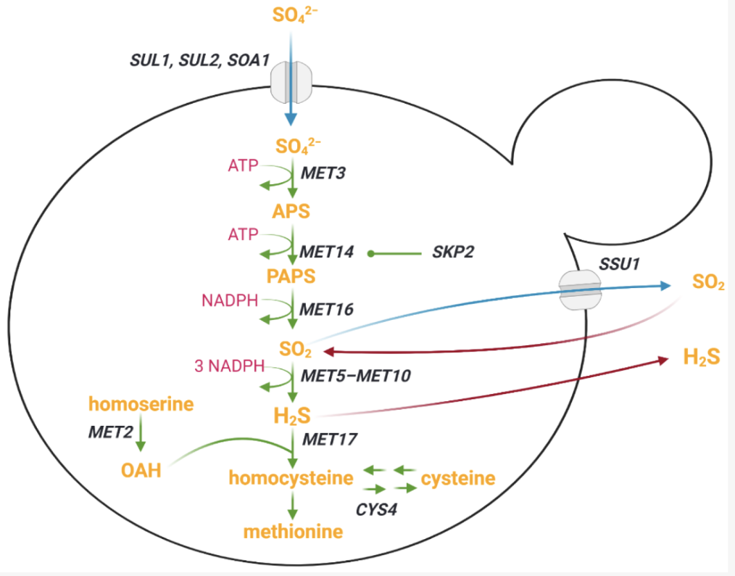

Fig _. Sulfur metabolism in the yeast *S. cerevisiae*.

(give general info about the process).

The production of H2S is related to the growth of the yeast. Periodic changes in H2S production (an inhibitor of respiration) were connected to an ultradian oscillation in respiration, with H2S being highest when respiration decreased, before declining with the onset of respiration (Sohn, Murray and Kuriyama 2000). Therefore, the production follows the dynamic presented in fig _.

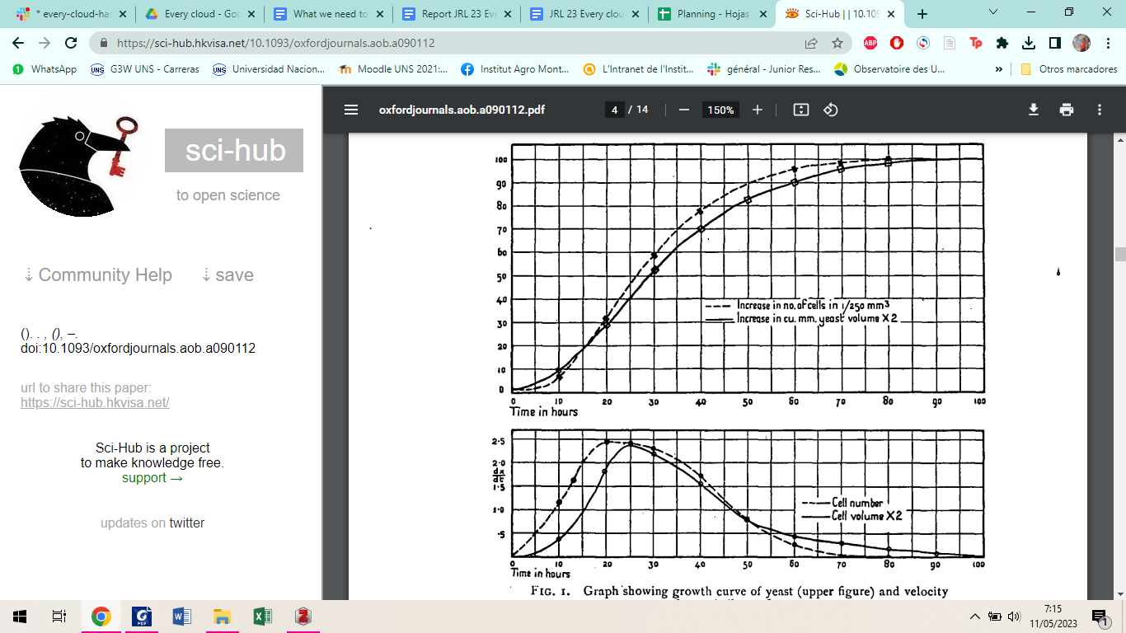

Fig _ Graph showing growth curve of yeast (upper figure) and velocity of growth (lower figure). From Richards, 1928.

This is the reason why the efficiency of S. c to remove copper and other heavy metals from wastewater may be optimised after more than 48 hs of fermentation.

Hypothesis

The aim of this project is to verify if *Saccharomyces cerevisiae* has an impact on the concentration of copper in wastewater with similar concentration as the water found in the Buriganga river, situated in Bangladesh, India. In addition, this research expects to confirm the decrease of copper concentration in water by the ${H_{2}S}_{}$ mechanism. This experiment will compare the efficiency of *S. c* at different concentrations of Cu 2+ after 72 hs of fermentation at a fixed pH.

# Methods

Fermentation was performed by S. cerevisiae (________) supplied from _______ in the form of _____. ( how it is maintained).

We followed the process subjected by Johansson et al., 2011. The preculture was inoculated under sterile conditions into agar plates containing the same solid culture medium. The media chosen was Yeast-Peptone-Dextrose (YPD) medium containing 1% (w/v) yeast extract, 2% (w/v) peptone, and 2% (v/v) glucose.The synthetic medium was autoclaved in 120°C for 20 min and then cooled to 30°C before use. The agar plates were inoculated using _____ (yeast). The temperature was regulated to 30°C in a shake-bath and they were kept for 48 h.

The media was sterilised in an autoclave at 121 C and 1 atm for 20 min before being inoculated by the yeast. The pH was maintained at 4.5 by addition of either 1 N NaOH or 1 N HCl when necessary. Johansson et al., 2011) proposed an initial cell concentration of ${10}^{8}$ CFU/ml is preferable.

A stock solution of Cu2+ (60 mg/L) was prepared by dissolving CuCl2∙ 2H2O (Fischer Scientific, USA) in ddH2O and stored at 57 ◦C. These concentrations simulate the ones found in rivers with high concentrations of copper.

The fermentations were performed in 13 ml TUBE flasks with a total fermentation volume of 6 ml. The medias were injected by Cu 2+ at different final concentrations: 2 mg/l, 4 mg/l, 6 mg/l, 8 mg/l and 10 mg/l, as can be observed in table _. One sample was not inoculated to have a control (S0). We made three repetitions for each concentration of copper. Samples were completed to a final volume of 6 ml with the same YPD and left to fermenter during 72 hs at an initial pH of 7 (+/- 0.3). The fermentation was performed at 30°C, and the agitation (in an orbital shake) was 150 rpm.

Table _

Composition of the copper solutions

| Solution | S5 | S4 | S3 | S2 | S1 | S0 |
| --- | --- | --- | --- | --- | --- | --- |
| [Cu] (mg/l) | 60 | 48 | 36 | 24 | 12 | 0 |
| [Cu]final (mg/l) | 10 | 8 | 6 | 4 | 2 | 0 |
| mCuSO4 (g) | 0,022 |  |  |  |  |  |
|  |  |  |  |  |  |  |
| Vtot (ml) | 100 | 10 | 10 | 10 | 10 | 10 |

Equation: S5 (60mg/L):Vtot=100ml, mCuSO4*5H2O= ((0,06/10)/68,546)* 159,609=0,014g

Where : molar masse of copper (Cu)= 68,546 g/mole

Molar masse of CuSO4*5H2O=159,609 g/mole

After 72 hs, we took samples of each repetition. The samples were centrifuged to remove all cell biomass. Using the kit ______ to detect the amount of copper precipitated. The samples were transferred in a cuvette and a black was prepared to assure the quality of the measurements. Secondly, we read the absorbance at 580 nm with the spectrometer for each cuvette three times in order to reduce error and compared the values with the witness (S5).

Convert absorbance to concentration of copper is automatically done by the tool (REFERENCE), the concentration in sample have to be integrated in an equation given in kit instructions and multiplied by the level of dilution.

# References

1. Daigger GT. Tools for future success. Water Environ Technol 2003;15(12):38–45.
2. “Modelling Heavy Metals in the Buriganga River System, Dhaka, Bangladesh: Impacts of Tannery Pollution Control | Elsevier Enhanced Reader.” Accessed May 10, 2023. https://doi.org/10.1016/j.scitotenv.2019.134090.